OriWin > SolveDP

# Screen comparison & questions

## First section quantity, tag keys etc. and fluid

(OriWin above, SolveDP to right)

Basically no issues translating OriWin to SolveDP for the:

* Tag plates
* Quantity
* Fluid (category)

**NOTE: OriWin does not allow Steam (saturated or superheated)**

Mixed flow is supported

Design temperature & pressure will be part of the fluid data in SolveDP (was further down in OriWin)

Question: should the “no (or incomplete) process data available” check box & system be present?

## Second section: flow, calculation type, limits, pipe properties

(this is OriWin)

Just one flow rate (meter max)

Question: do you still want the ability to override limits etc. as per OriWin, and what, if any, security capability should be provided?

Question: Drain/Vent – is this now a SAP selection? (different to how it works in OriWin) – if so it’s not in the SAP data unlike FPD150 –please clarify – need to know if you want it to work as per OriWin or as per SolveDP/Orifice.

Question: Support diameter - Do you want the SolveDP/Orifice “intelligence” for RTJ Support diameter or the OriWin approach (they’re quite different)

BIG Question: Do you want that yellow box – calculation required? (single, multi stage etc.) – and if so how does that fit with the way you’ve detailed the outputs – OriWin has quite a different output layout to SolveDP due to multi-stage potential. If you don’t want it how is it supposed to work?

## Third section: materials etc.

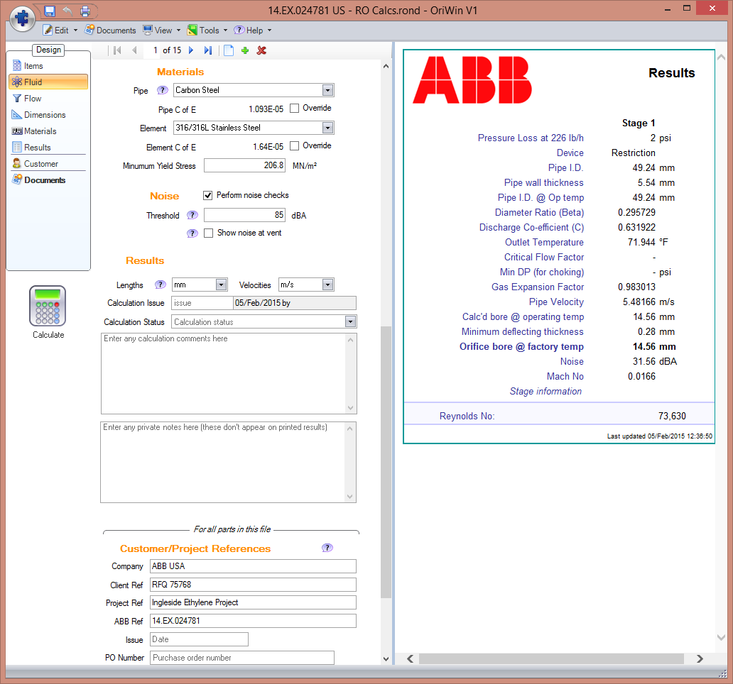Question: are you happy to have the SolveDP approach here (no override of “known” materials”)?

## Fourth section: SAP inputs

Not in OriWin; so new for SolveDP implementation, will be along the lines of Orifice plates

## Results

OriWin has a quite different results layout wrt other SolveDP products due to the multi-stage ability:

|  |  |
| --- | --- |
| [C:\Users\Michael\AppData\Local\Temp\Logo.PNG](http://www.abb.com/) | Results |
|  | |
| |  |  |  |  | | --- | --- | --- | --- | |  | **Stage 1** | **Stage 2** |  | | Pressure Loss at 4000 lb/h | 25.226 | 3.7736 | psi | | Pipe I.D. @ Op temp | 24.32 | 24.32 | mm | | Diameter Ratio (Beta) | 0.326684 | 0.494379 |  | | Discharge Co-efficient (C) | 0.640403 | 0.705102 |  | | Pipe Velocity | 1.51356 | 1.51356 | m/s | | Cavitation Number | 1.22 | 5.20 |  | | Quality correction factor Fx | - | - |  | | Calc'd bore @ operating temp | 7.94 | 12.02 | mm | | Minimum deflecting thickness | 0.48 | 0.16 | mm | | **Orifice bore @ factory temp** | **7.94** | **12.01** | **mm** | | Noise | 64.28 | 44.74 | dBA | | Mach No |  |  |  | | *Stage information* | Stage limited by:Cavitation |  |  | | |
| Reynolds No: | 92,268 |
| Results generated 05/Feb/2015 13:48:36 | |

Is this (OriWin) layout wanted?